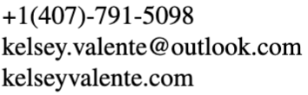
Kelsey Valente
Sound & Lighting

EDUCATION
University of West Florida, BFA Musical Theatre & BA Arts Administration Spring 2026
Minors in Electrical Engineering and Kugelman Honors Program

PRODUCTION EXPERIENCE

Macbeth | Electrics Crew | University of West Florida | Dylan Tillery, LD
The Marvelous Wonderettes | Deck Audio | University of West Florida | Drake Miller, TD
Emma | Light Board Operator | University of West Florida | Dylan Tillery, LD
Nine | Electrics Crew | University of West Florida | Charles Houghton, LD
The Great American Trailer Park Christmas Musical | Deck Audio | University of West Florida | Kayla Stephenson, TD
Blithe Spirit | Electrics Crew | University of West Florida | Charles Houghton, LD
Rocky Horror Picture Show Shadowcast | Spotlight Operator | University of West Florida | Glenn Breed, dir.

TRAINING

Lighting Technology, Technical Theatre
SPECIAL SKILLS
Light Board Operations, Theatrical Photography, Adobe (Photoshop, InDesign, Lightroom, Illustrator)

